Experiment 4: 8-Puzzle Problem

Aim
To solve the 8-Puzzle problem using Artificial Intelligence search.

Objective
To arrange the tiles in the correct order by moving the blank space.

Algorithm
- Define the initial state.
- Define the goal state.
- Find the position of the blank tile.
- Move the blank tile (up, down, left, right) whenever possible.
- Repeat until the goal state is reached.

Python code
puzzle = [
[1, 2, 3],
[4, 0, 6],
[7, 5, 8]
]

goal = [
[1, 2, 3],
[4, 5, 6],
[7, 8, 0]
]

def display(board):
for row in board:
print(row)
print()

print("Initial State:")
display(puzzle)

# Move 1: Swap 0 with 5
puzzle[1][1], puzzle[2][1] = puzzle[2][1], puzzle[1][1]
print("Move 1:")
display(puzzle)

# Move 2: Swap 0 with 8
puzzle[2][1], puzzle[2][2] = puzzle[2][2], puzzle[2][1]
print("Move 2:")
display(puzzle)

if puzzle == goal:
print("Goal State Reached")
else:
print("Goal Not Reached")

Flowchart

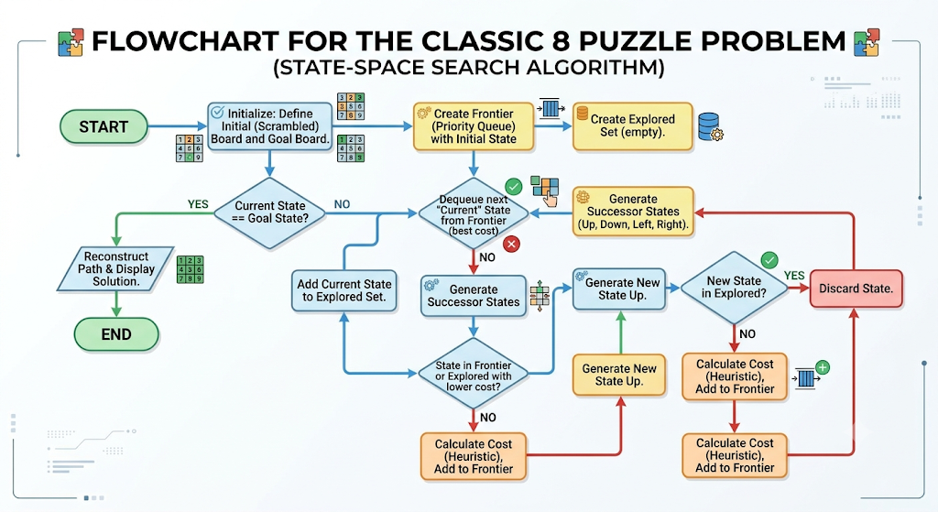

Output:

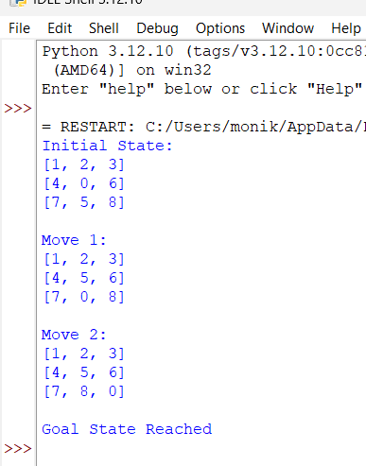

Result:
The 8 Puzzle Problem was executed successfully, and the goal state was achieved.

